**#21396** - <https://redmine.vnc.biz/issues/21396>

1. **Description**:

The multiple lines input box in judaspriest ([https://z86judaspriest.zimbra-vnc.de](https://z86judaspriest.zimbra-vnc.de/)) does not fit in the window.

Tested with Chrome Version 44.0.2403.89 (64-bit) and Chromium.

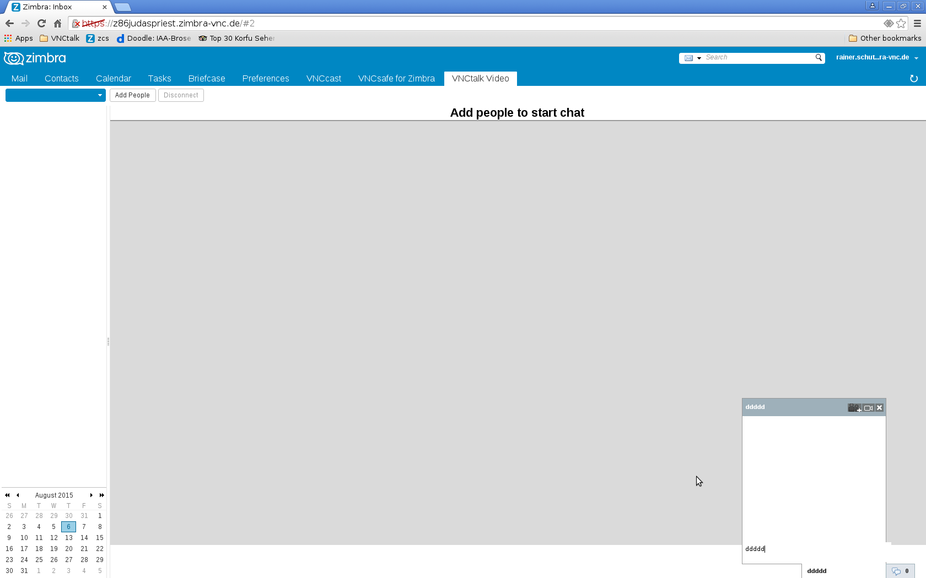

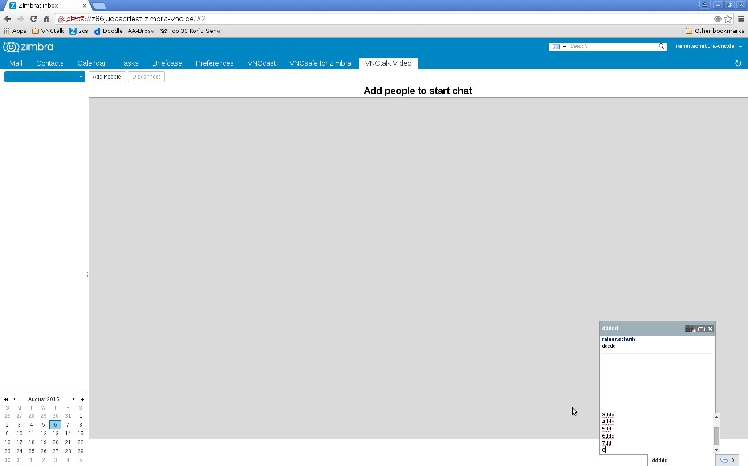

1. **Analytic**
   1. **Root cause**:
   2. **Solutions**:
2. **Implementation**
   1. **Code:**

* At Zimbra 8.6, "jm-send-message" doesn't have "box-sizing: border-box", need to apply it.

|  |
| --- |
| #jappix_mini textarea.jm_send-messages{  width: 260px;  min-height: 16px;  max-height: 80px;  line-height: 1.5em;  margin-left: auto;  margin-right: auto;  padding: 5px;  height: 26px;  box-sizing: border-box; } |

* At Zimbra 8.6, the focus of chat window doesn't display border:

|  |
| --- |
| #jappix_mini textarea.jm_send-messages:focus{  border: 1px solid #999999; } |

* Form content textarea element is different height between zimbra 8.0 and 8.6. Solution use "jm_send-message" to get outerHeight:

|  |
| --- |
| self.chatEvents = function(type, xid, hash) { ...  height_send = current_sel.find('.jm_send-messages').outerHeight() + 4;  ... } |